Relay

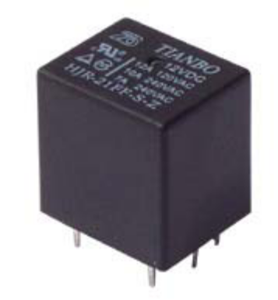
RELAYS:

Relays are used throughout the automobile. Relays which come in assorted sizes, ratings, and applications, are used as remote control switches. A typical vehicle can have 20 relays or more.

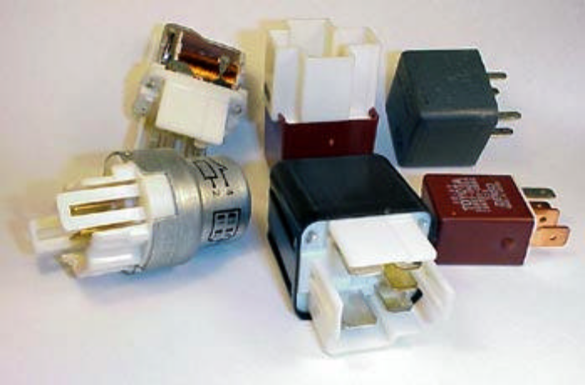

A relay is an electrically operated switch. Current flowing through the coil of the relay creates a magnetic field which attracts a lever and changes the switch contacts. The coil current can be on or off so relays have two switch positions and most have double throw (changeover) switch contacts.
Relays allow one circuit to switch a second circuit which can be completely separate from the first. For example a low voltage battery circuit can use a relay to switch a 230V AC mains circuit. There is no electrical connection inside the relay between the two circuits; the link is magnetic and mechanical.
The coil of a relay passes a relatively large current, typically 30mA for a 12V relay, but it can be as much as 100mA for relays designed to operate from lower voltages. Most ICs (chips) cannot provide this current and a transistor is usually used to amplify the small IC current to the larger value required for the relay coil.
Relays are usually SPDT or DPDT but they can have many more sets of switch contacts, for example relays with 4 sets of changeover contacts are readily available. Most relays are designed for PCB mounting but you can solder wires directly to the pins providing you take care to avoid melting the plastic case of the relay.
The supplier's catalogue should show you the relay's connections. The coil will be obvious and it may be connected either way round. Relay coils produce brief high voltage 'spikes' when they are switched off and this can destroy transistors and ICs in the circuit. To prevent damage you must connect a protection diode across the relay coil.
The relay's switch connections are usually labeled COM, NC and NO:
- COM = Common, always connect to this; it is the moving part of the switch.
- NC = Normally Closed, COM is connected to this when the relay coil is off.
- NO = Normally Open, COM is connected to this when the relay coil is on.
Connect to COM and NO if you want the switched circuit to be on when the relay coil is on.
Connect to COM and NC if you want the switched circuit to be on when the relay coil is off.

Choosing a relay:

You need to consider several features when choosing a relay:

Physical size and pin arrangement:

If you are choosing a relay for an existing PCB you will need to ensure that its dimensions and pin arrangement are suitable. You should find this information in the supplier's catalogue. Coil voltage:The relay's coil voltage rating and resistance must suit the circuit powering the relay coil. Many relays have a coil rated for a 12V supply but 5V and 24V relays are also readily available. Some relays operate perfectly well with a supply voltage which is a little lower than their rated value.
Coil resistance:

The circuit must be able to supply the current required by the relay coil. You can use Ohm's law to calculate the current:
Relay coil current = | supply voltage
Relay coil current = | coil resistance
For example: A 12V supply relay with a coil resistance of 400 passes a current of 30mA. This is OK for a 555 timer IC (maximum output current 200mA), but it is too much for most ICs and they will require a transistor to amplify the current.
Switch ratings (voltage and current):
The relay's switch contacts must be suitable for the circuit they are to control. You will need to check the voltage and current ratings. Note that the voltage rating is usually higher for AC, for example: "5A at 24V DC or 125V AC".
Switch contact arrangement (SPDT, DPDT etc):
Most relays are SPDT or DPDT which are often described as "single pole changeover" (SPCO) or "double pole changeover" (DPCO).

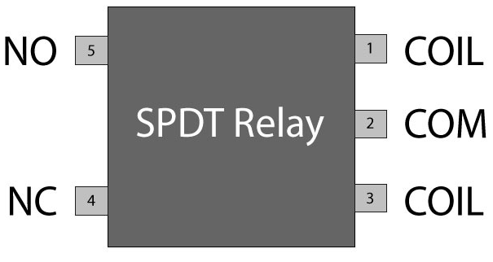
Protection diodes for relays:

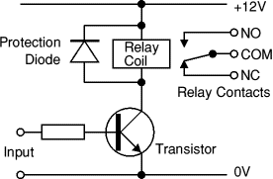
Transistors and ICs must be protected from the brief high voltage produced when a relay coil is switched off. The diagram shows how a signal diode (eg. 1N4007) is connected 'backwards' across the relay coil to provide this protection.
Current flowing through a relay coil creates a magnetic field which collapses suddenly when the current is switched off. The sudden collapse of the magnetic field induces a brief high voltage across the relay coil which is very likely to damage transistors and ICs. The protection diode allows the induced voltage to drive a brief current through the coil (and diode) so the magnetic field dies away quickly rather than instantly. This prevents the induced voltage becoming high enough to cause damage to transistors and ICs.
Relays and transistors compared:

Like relays, transistors can be used as an electrically operated switch. For switching small DC currents (<1A) at low voltage they are usually a better choice than a relay. However, transistors cannot switch AC (such as mains electricity) and in simple circuits they are not usually a good choice for switching large currents (>5A). In these cases a relay will be needed, but note that a low power transistor may still be needed to switch the current for the relay's coil! The main advantages and disadvantages of relays are listed below:

RELAY APPLICATIONS:

Relays are remote control electrical switches that are controlled by another switch, such as a horn switch or a computer as in a power train control module. Relays allow a small current flow circuit to control a higher current circuit. Several designs of relays are in use today, 3- pin, 4-pin, 5-pin, and 6-pin, single switch or dual switches.

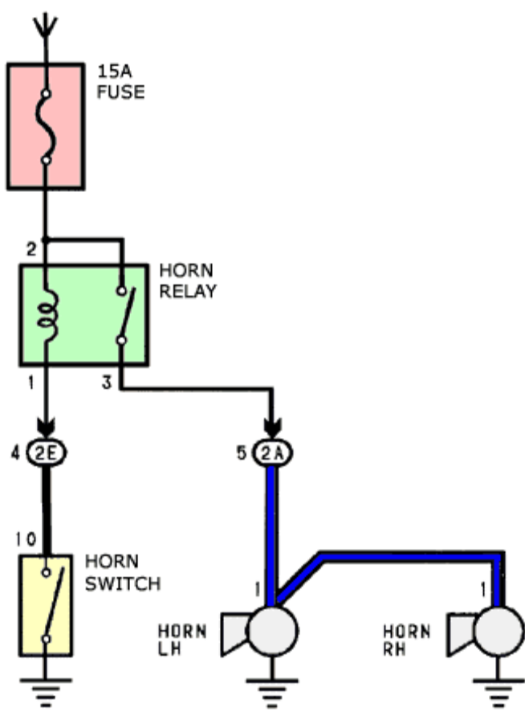

RELAY OPERATION:

When no voltage is applied to pin 1, there is no current flow through the coil. No current means no magnetic field is developed, and the switch is open. When voltage is supplied to pin 1, current flow though the coil creates the magnetic field needed to close the switch allowing continuity between pins 2 and 4.

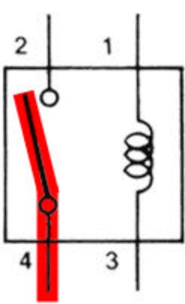

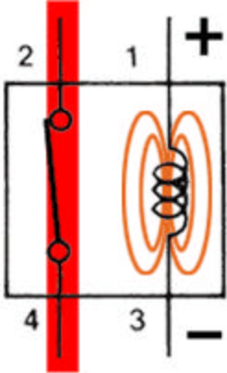

ACTUAL RELAY DESIGN:

Current flows through the control coil, which is wrapped around an iron core. The iron core intensifies the magnetic field. The magnetic field attracts the upper contact arm and pulls it down, closing the contacts and allowing power from the power source to go to the load
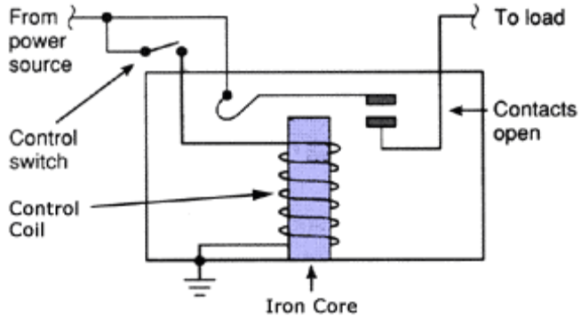

STANDARD MINI ISO RELAYS TYPES:

Below are two popular standard MINI ISO relay configurations. The size of a ISO Standard MINI relay is a 1" square cube. Both 4 and 5 pins designs are used. 4 PIN
MINI RELAY:

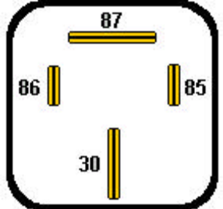

PRACTICAL TESTING:

Once the pins have been identified, energize the control circuit by supplying B+ to pin 1 and a ground to pin 3. A faint "click" will be heard; although this "click" means the switch has moved (closed), it does not mean the relay is good. The load circuit switch contacts could still be faulty (high resistance), and further testing is required. A common mistake technicians make is they hear a "click" and assume the relay is good. Take the extra step and verify operation.

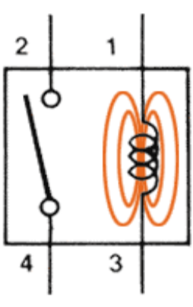
OPERATIONAL CHECK WITH VOLTMETER:

A voltmeter can be substituted in place of a test light; however be aware if the contacts are partially burned, the voltmeter will show voltage indicating good contact even when bad. Remember high impedance digital voltmeters draw almost no current. Energize the relay (control side) by supplying B+ to pin 1 and a ground to pin 3. A click should be heard. With the relay still energized supply B+ to pin 2 of the load circuit. Connect the RED lead to pin 4 and the BLACK lead to ground. The voltmeter will indicate source voltage (12V). Deenergize (remove B+) the control circuit at pin 1; the voltmeter should now read "zero". Reenergize the relay and the voltmeter should return to 12 volts.

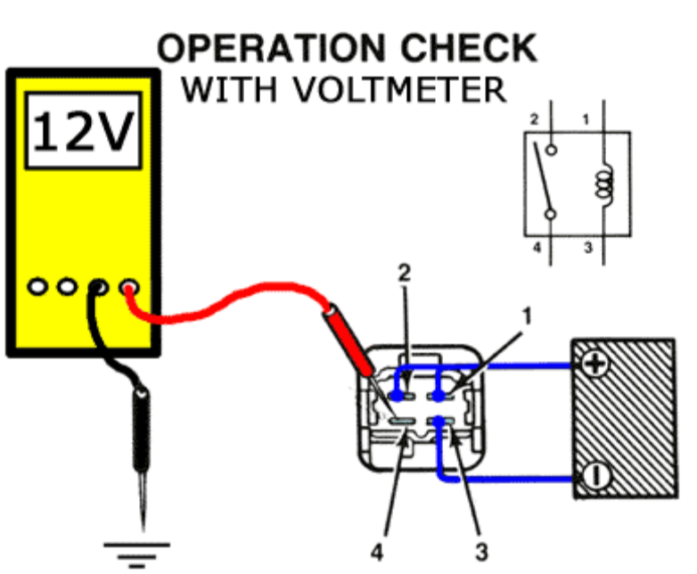

CAUTION:

Testing relays with built in clamping diodes require a special procedure. These relays are polarity sensitive; placing B+ to the wrong pin (backwards) while performing a practical test will forward bias the diode and damage the diode, thus destroying the protective quality of the diode.

OPERATIONAL CHECK FOR RELAY VOLTAGE SUPPRESSION DIODES:

An ANALOG OHMMETER must be used. This test cannot be performed with a digital meter. The analog meter sends out a higher voltage which is required to forward bias the diode. Place the ohmmeter across the control circuit and record reading. Reverse the leads and check the control circuit again. A functioning diode will be indicated by have two different readings. A faulty diode will have the same reading in both directions. Current from the ohmmeter flows through the control coil, in one direction. By reversing the leads, you send current in the opposite direction through the control coil. One of the two directions the diode will be forward biased(on), creating two paths for current thus lowering resistance. With the leads in the other direction, the diode in will be reversed biased (off) creating only one path, with higher resistance.

SPDT Relay:

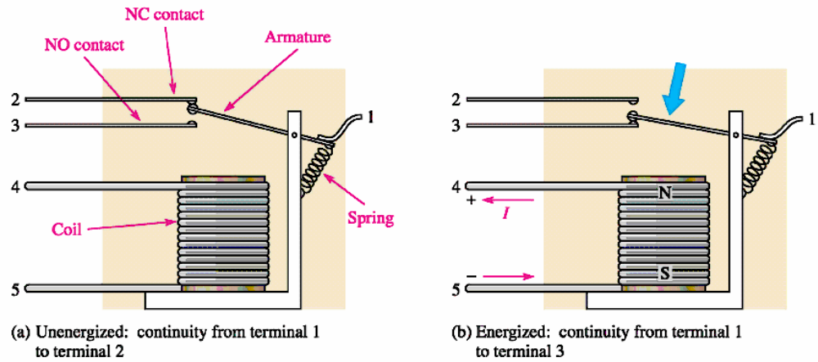
Reed Relay:

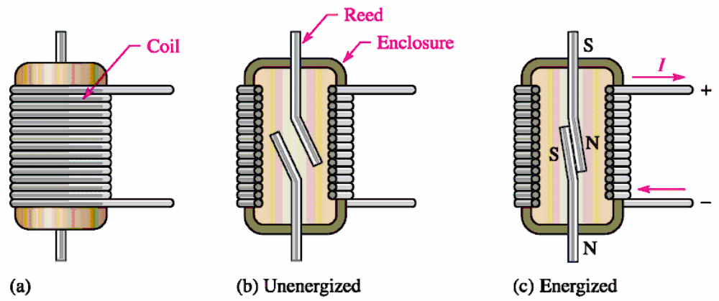

Advantages of relays:
- Relays can switch AC and DC, transistors can only switch DC.
- Relays can switch higher voltages than standard transistors.
- Relays are often a better choice for switching large currents (> 5A).
- Relays can switch many contacts at once.
Disadvantages of relays:
- Relays are bulkier than transistors for switching small currents.
- Relays cannot switch rapidly (except reed relays), transistors can switch many times per second.
- Relays use more power due to the current flowing through their coil.
- Relays require more current than many ICs can provide, so a low power transistor may be needed to switch the current for the relay's coil.

